COS209 – PROJECT USER MANUAL

HDICT

Thaw Myo Han

2024

This is the Main Page of ***SEEKER*** Sneaker Online Store.

Search Icon | Profile | Cart

Direct to New Releases

Note: If a new customer clicks profile icon, it will redirect to login page.

Note: If a customer click search icon, search box will pop up.

Note: If there are 3 sneakers in a cart, 3 will be displayed next to cart icon.

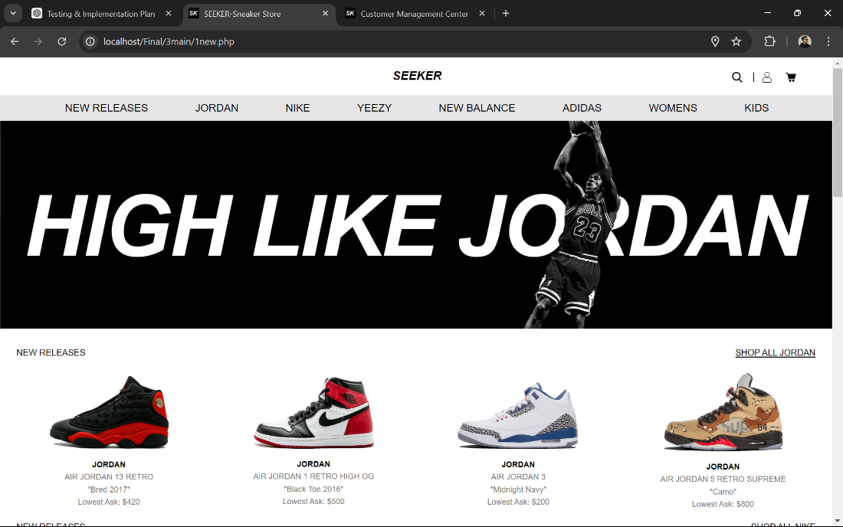

Lists of new released sneakers by each brand and also show some info like name and lowest price by sizes.

Navigation Bar

Automatic Slide Posters and it will redirect to relative pages.

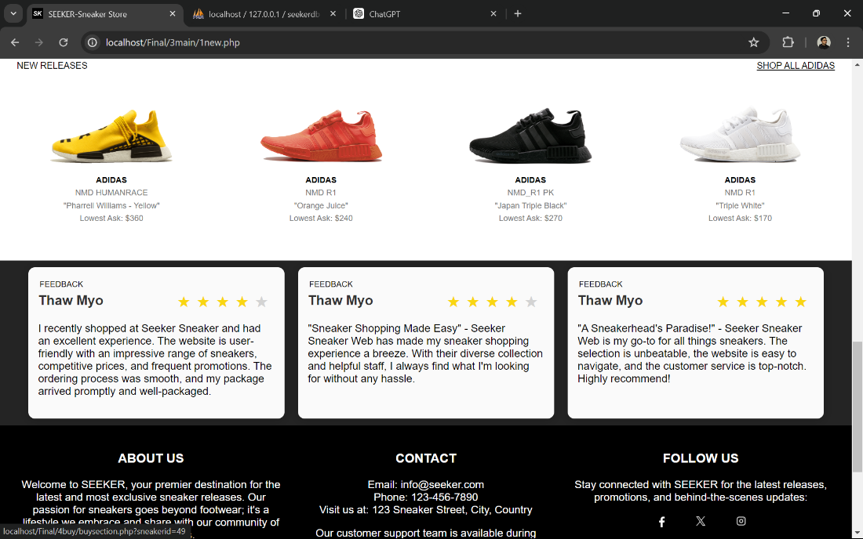

About Us and Contact Sections

Star Ratings and Reviews from customers

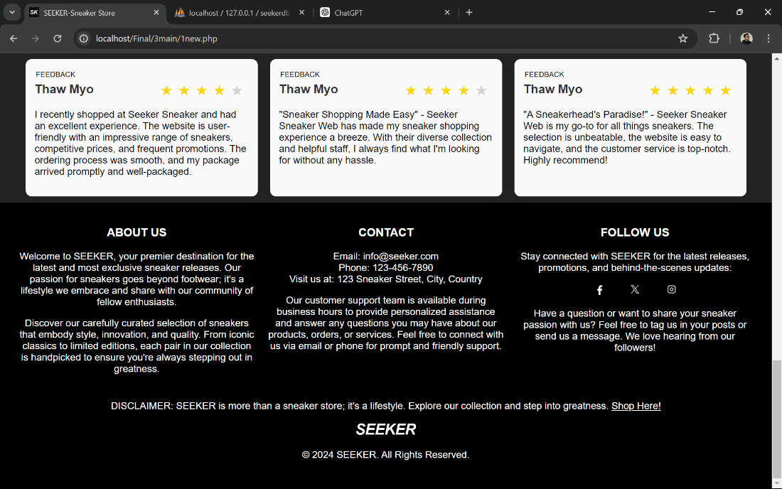

Figure 1 Main Page of SEEKER Sneaker Online Store

This is the page which display Sneaker’s available Sizes and Prices, and Details. Other sneakers also will be shown in YOU MAY LIKE section.

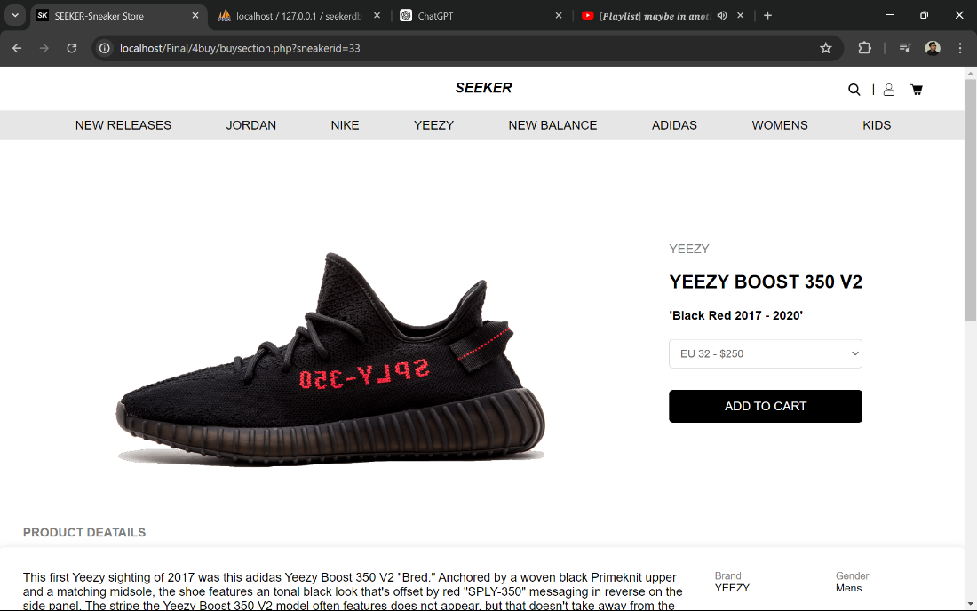

Available Sizes & Prices

Button to add sneakers into a cart.

High quality image of Sneaker and every single detail of sneaker will be provided. Available sizes and prices will be in the select box.

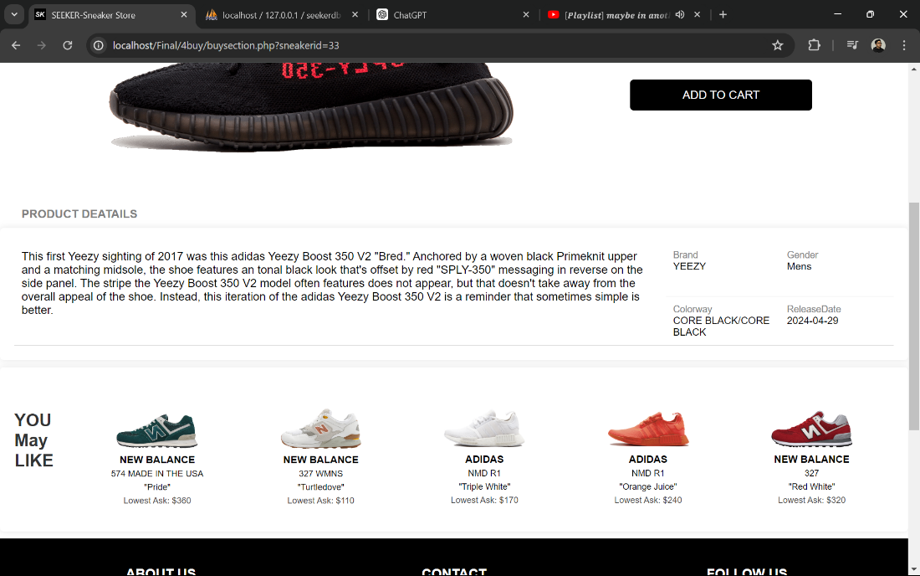

More Sneakers in YOU MAY LIKE.

Figure 2 Buy Section of SEEKER Sneaker Online Store

This is Profile of customer which can edit information and view orders history.

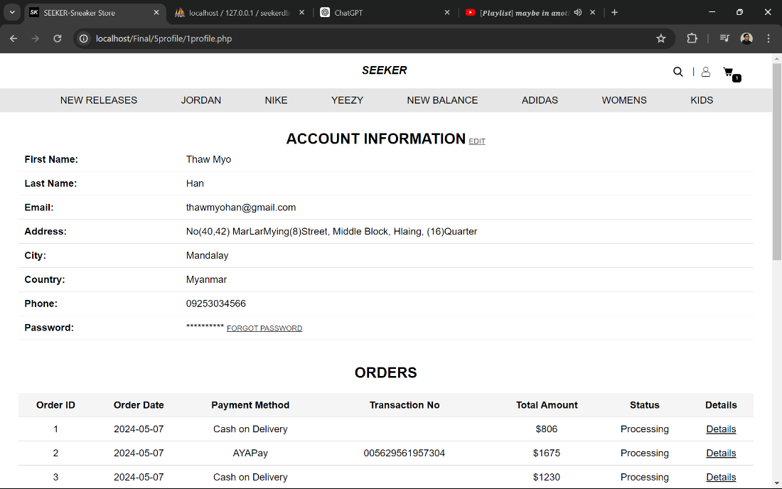

Button to change password or forgot password with security question.

Edit Button to display popup form and then edit information.

Account Information Section

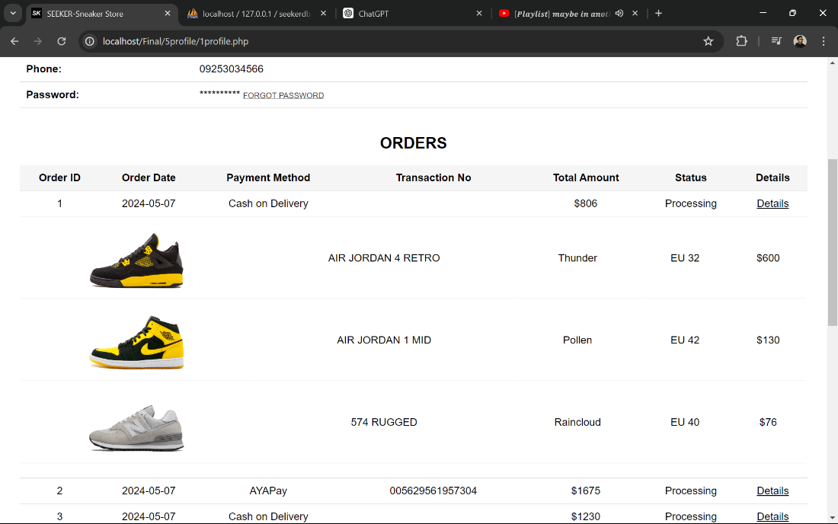

Orders History Section

Details Button to view order’s details

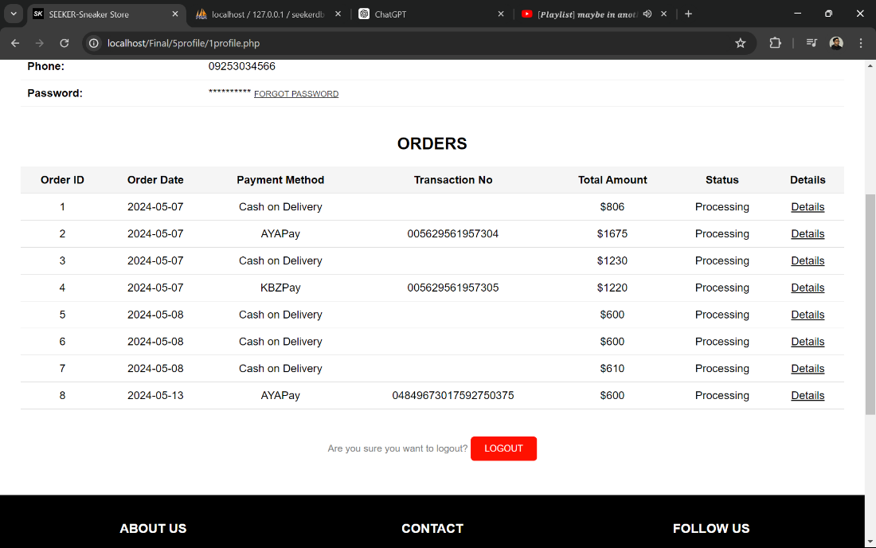

LOGOUT Button

Figure 3 Profile Page of SEEKER Sneaker Online Store

This is Cart Page to view all the sneakers that added to cart by a customer.

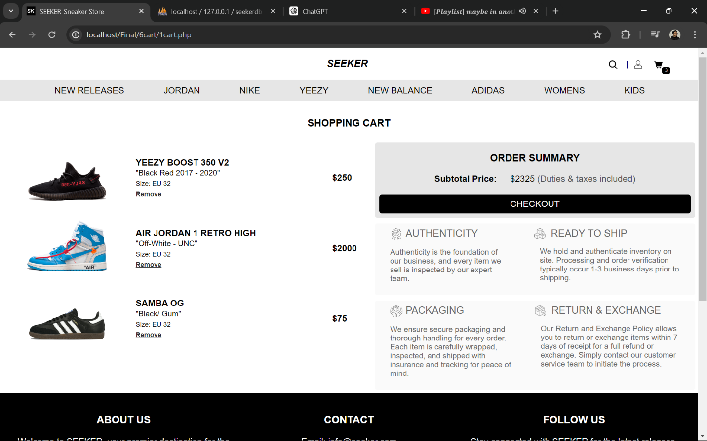

Checkout button to continue the process

Subtotal of all sneakers

Remove Button to remove sneaker



Figure 4 Cart Page of SEEKER Sneaker Online Store

This is a page which create CHECKOUT PROCESS.

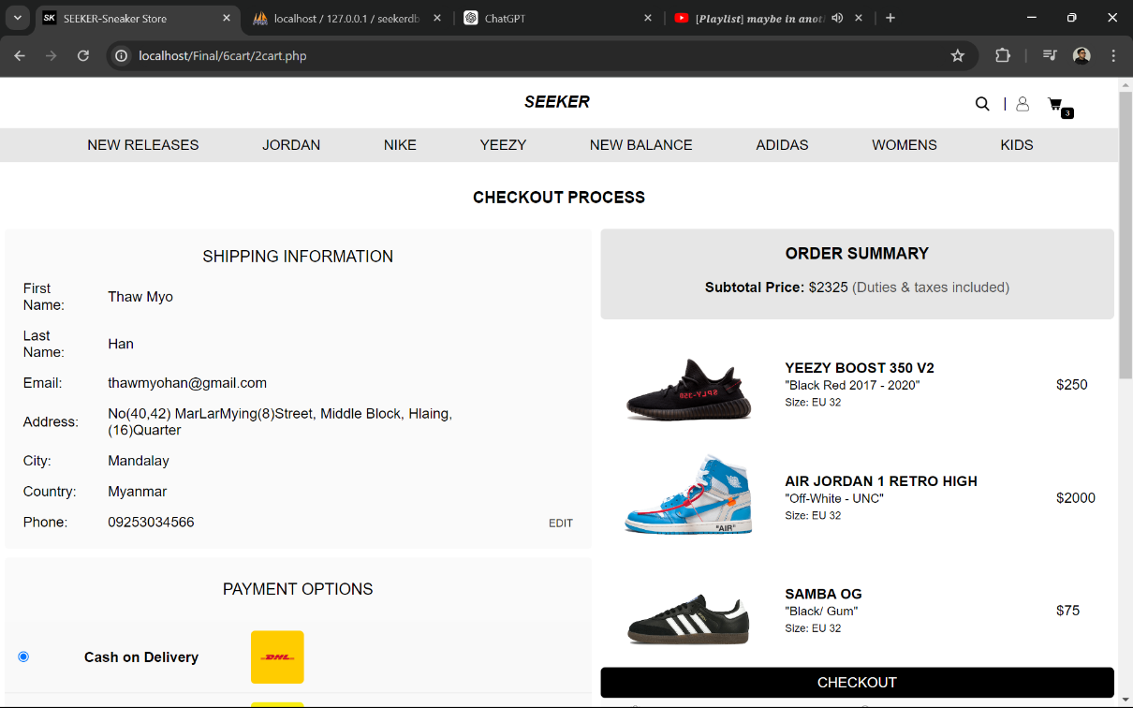

Check out Button to make a order

A customer can check sneakers and subtotal price and sizes in this section.

Various Payment Options with radio buttons to select which payment do a customer want to pay.

SHIPPING INFORMATION SECTION

Edit button to pop up edit form.

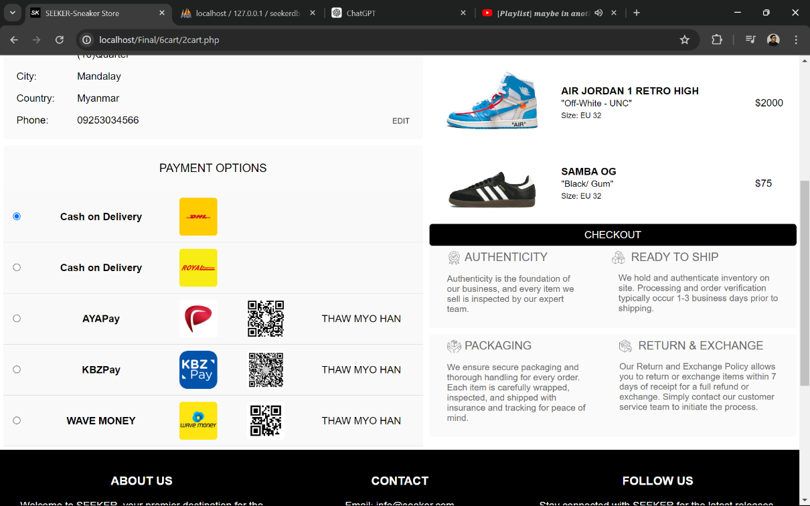

Figure 5 Checkout Page of SEEKER Sneaker Online Store

This pop up form will be appeared when a customer selects an option – Cash on Delivery.

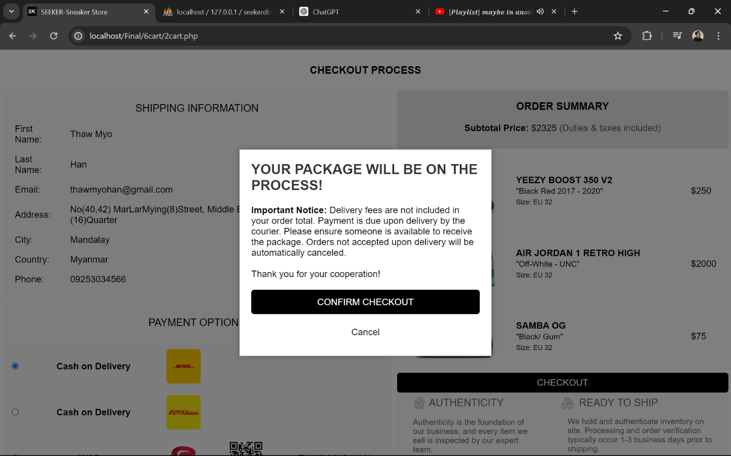

Button to Confirm Checkout and get receipt.

Figure 6 Confirmation Box of SEEKER Sneaker Online Store

This pop up form will be appeared when a customer selects an option except from Cash on Delivery.

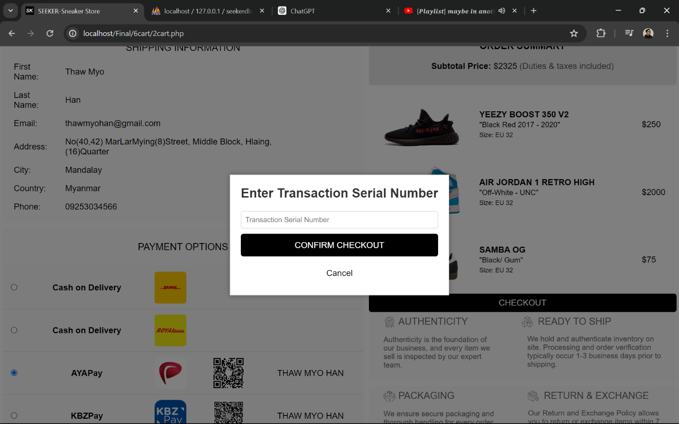

Add transaction number and Button to Confirm Checkout and get receipt.

Figure 7 Confirmation Box of SEEKER Sneaker Online Store

This is the Receipt of an order which a customer recently made and a customer can review shopping experience or skip.

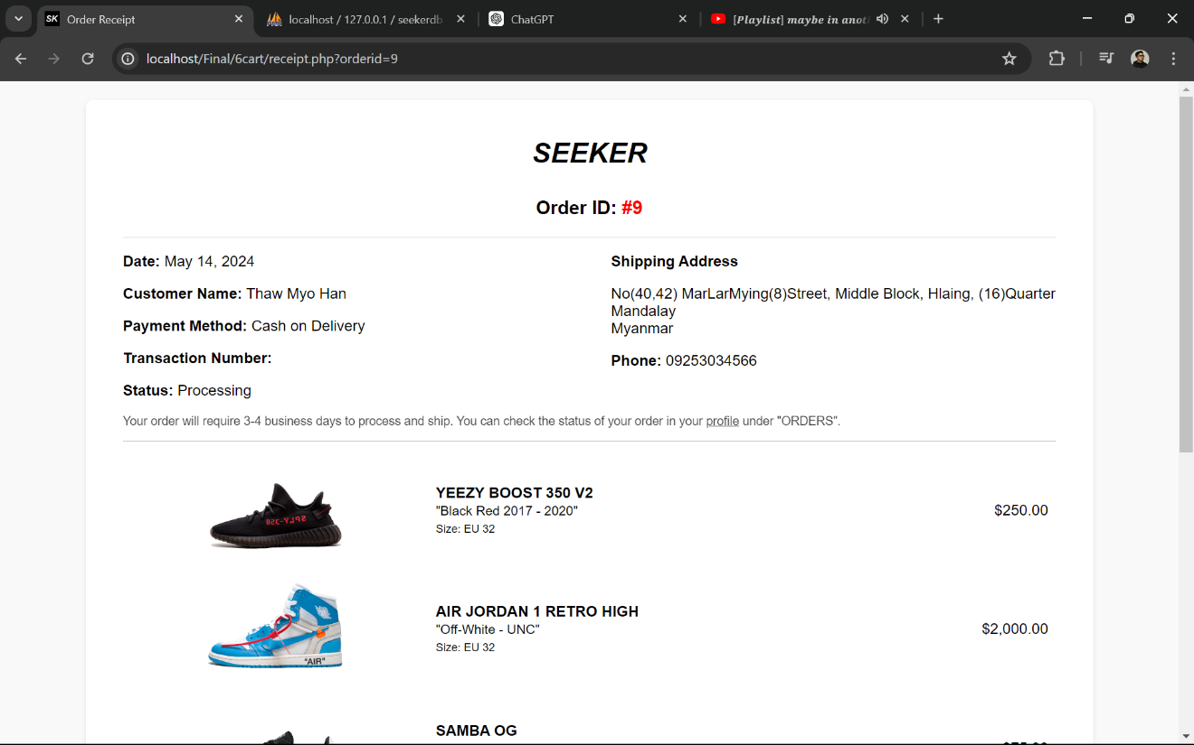

Order’s Details

Shipping Info and Payment

Order ID

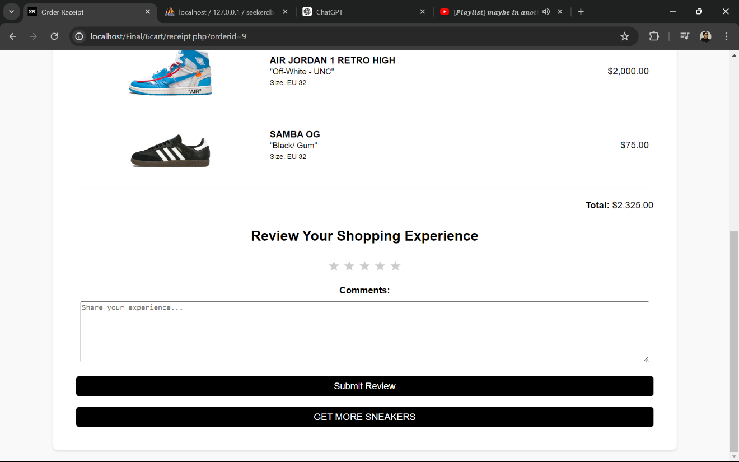

Skip and go back to main page.

Review Sections with star rating and text field and button to submit.

Figure 8 Receipt of SEEKER Sneaker Online Store